Test Case: tc005_SPX_Dev5_Crear_Requisicion_Spot_Con_FAD_Tipo_Cobro_Project
Step 1 - Enter username and password and click to button Enter: Credentials Entered
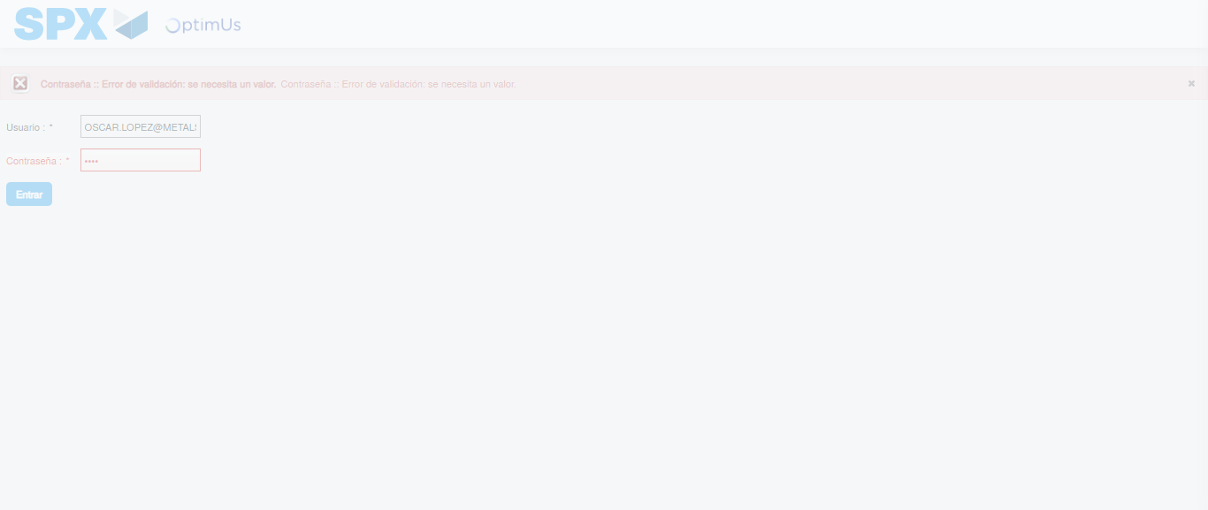Image file-name: QC_Testing-tc005_SPX_Dev5_Crear_Requisicion_Spot_Con_FAD_Tipo_Cobro_Project-1784571677693

Step 2 - Select to UEN and Access to Spot Buy Requisitions : UEN Correctly selected and Correct access
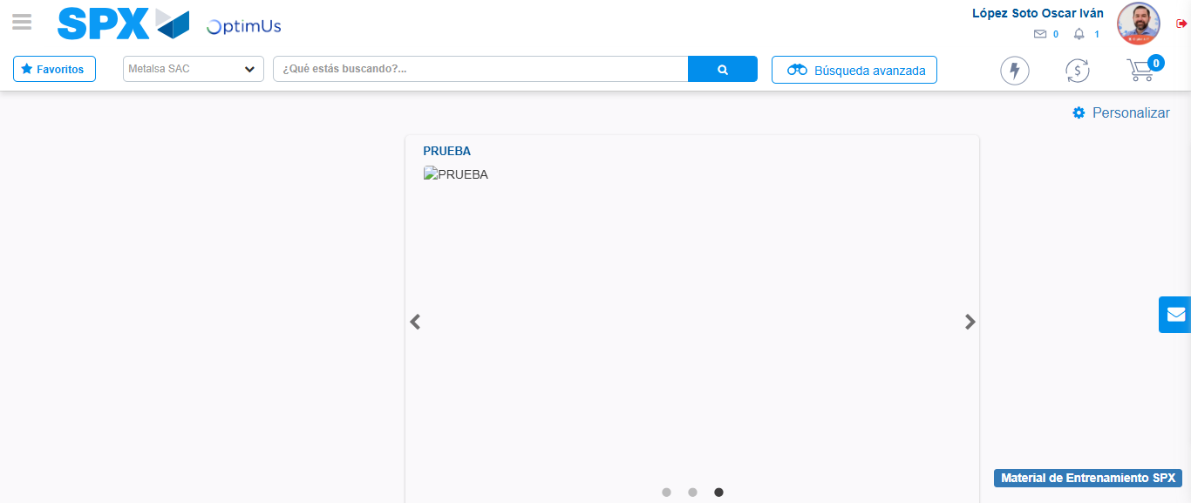Image file-name: QC_Testing-tc005_SPX_Dev5_Crear_Requisicion_Spot_Con_FAD_Tipo_Cobro_Project-1784571757586

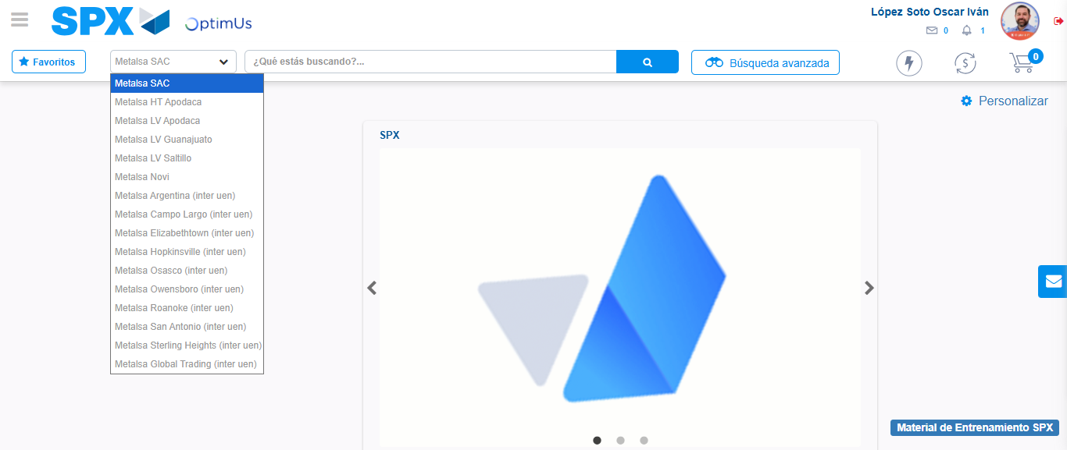Image file-name: QC_Testing-tc005_SPX_Dev5_Crear_Requisicion_Spot_Con_FAD_Tipo_Cobro_Project-1784571760192

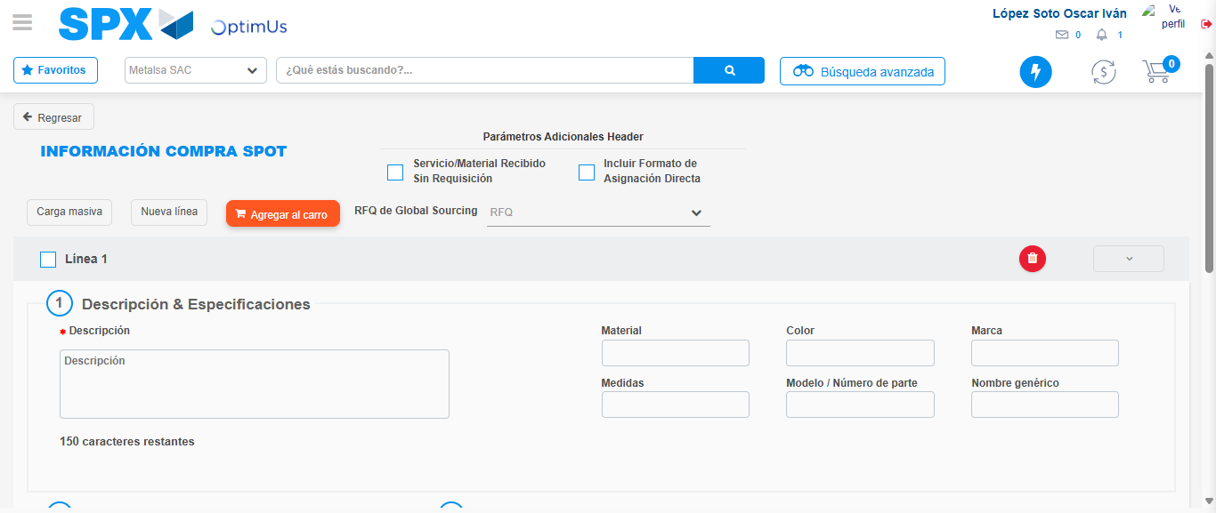Image file-name: QC_Testing-tc005_SPX_Dev5_Crear_Requisicion_Spot_Con_FAD_Tipo_Cobro_Project-1784571779942

Step 3 - Add FAD to Requisition: FAD Successfully Added
Image file-name: QC_Testing-tc005_SPX_Dev5_Crear_Requisicion_Spot_Con_FAD_Tipo_Cobro_Project-1784571780189

Image file-name: QC_Testing-tc005_SPX_Dev5_Crear_Requisicion_Spot_Con_FAD_Tipo_Cobro_Project-1784571780390

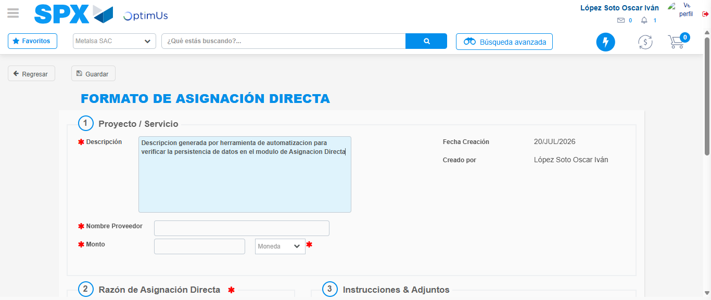Image file-name: QC_Testing-tc005_SPX_Dev5_Crear_Requisicion_Spot_Con_FAD_Tipo_Cobro_Project-1784571783266

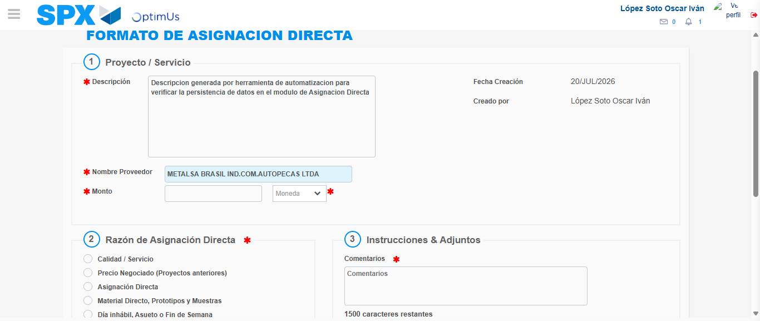Image file-name: QC_Testing-tc005_SPX_Dev5_Crear_Requisicion_Spot_Con_FAD_Tipo_Cobro_Project-1784571789499

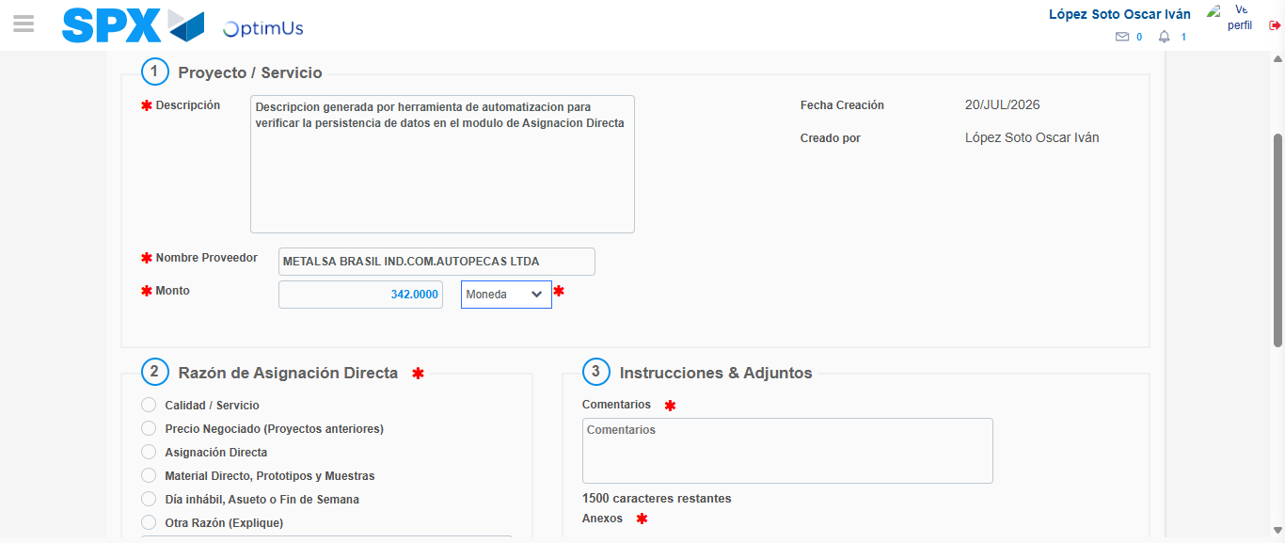Image file-name: QC_Testing-tc005_SPX_Dev5_Crear_Requisicion_Spot_Con_FAD_Tipo_Cobro_Project-1784571789996

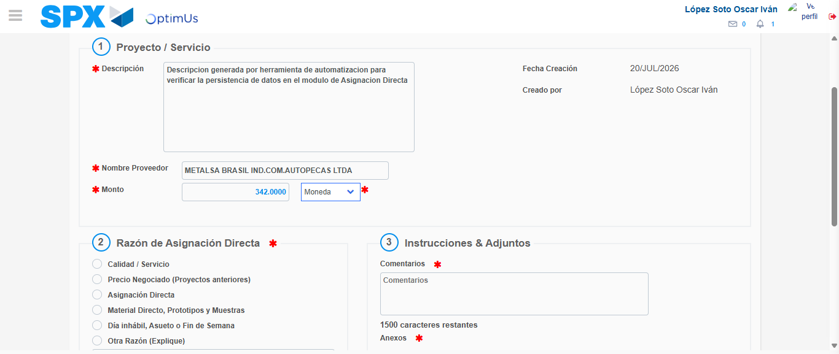Image file-name: QC_Testing-tc005_SPX_Dev5_Crear_Requisicion_Spot_Con_FAD_Tipo_Cobro_Project-1784571790192

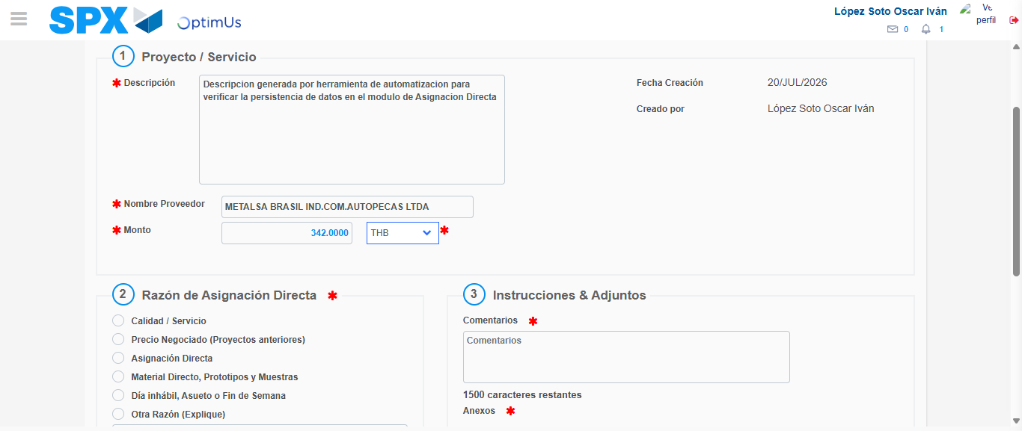Image file-name: QC_Testing-tc005_SPX_Dev5_Crear_Requisicion_Spot_Con_FAD_Tipo_Cobro_Project-1784571790581

Image file-name: QC_Testing-tc005_SPX_Dev5_Crear_Requisicion_Spot_Con_FAD_Tipo_Cobro_Project-1784571790751

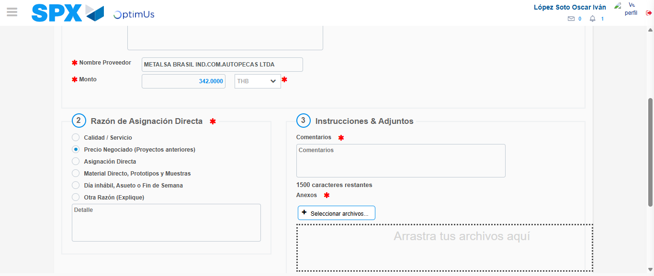Image file-name: QC_Testing-tc005_SPX_Dev5_Crear_Requisicion_Spot_Con_FAD_Tipo_Cobro_Project-1784571791603

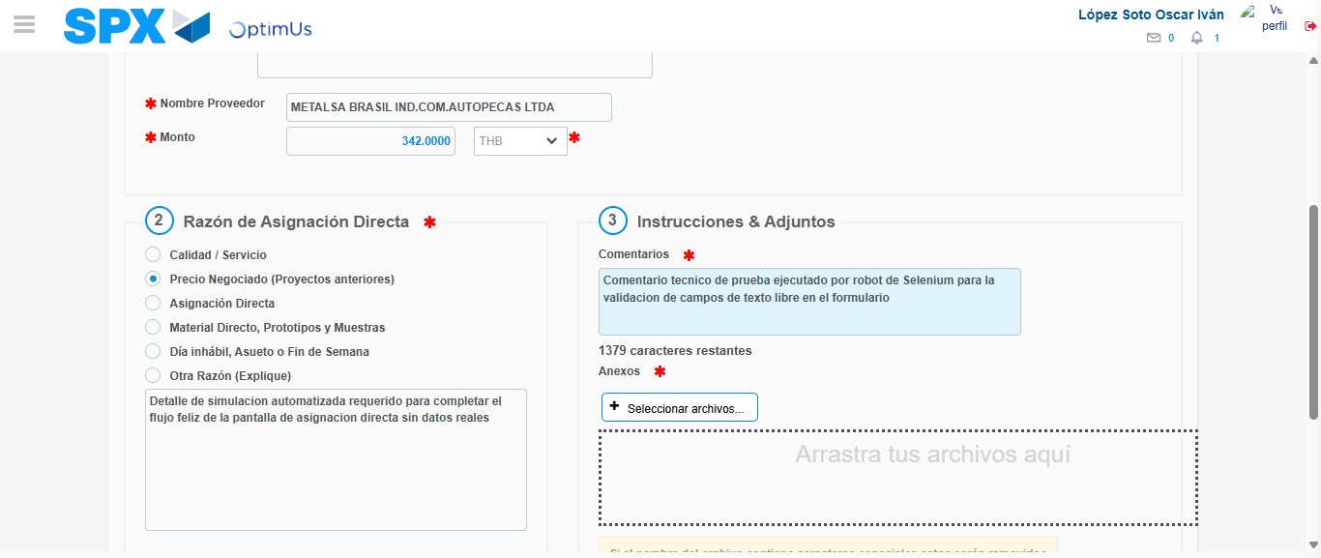Image file-name: QC_Testing-tc005_SPX_Dev5_Crear_Requisicion_Spot_Con_FAD_Tipo_Cobro_Project-1784571802688

Image file-name: QC_Testing-tc005_SPX_Dev5_Crear_Requisicion_Spot_Con_FAD_Tipo_Cobro_Project-1784571803430

Step 4 - Data Capture Spot Buy Requisition: Data captured correctly
Image file-name: QC_Testing-tc005_SPX_Dev5_Crear_Requisicion_Spot_Con_FAD_Tipo_Cobro_Project-1784571780189

Image file-name: QC_Testing-tc005_SPX_Dev5_Crear_Requisicion_Spot_Con_FAD_Tipo_Cobro_Project-1784571780390

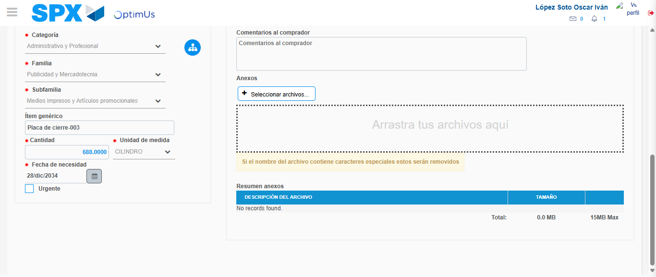Image file-name: QC_Testing-tc005_SPX_Dev5_Crear_Requisicion_Spot_Con_FAD_Tipo_Cobro_Project-1784571817688

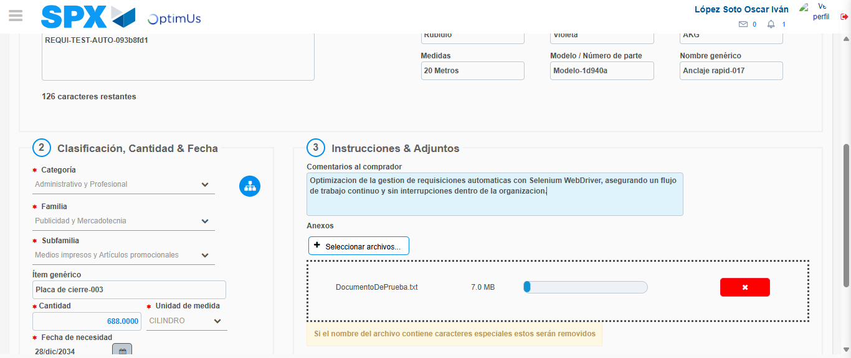Image file-name: QC_Testing-tc005_SPX_Dev5_Crear_Requisicion_Spot_Con_FAD_Tipo_Cobro_Project-1784571818543

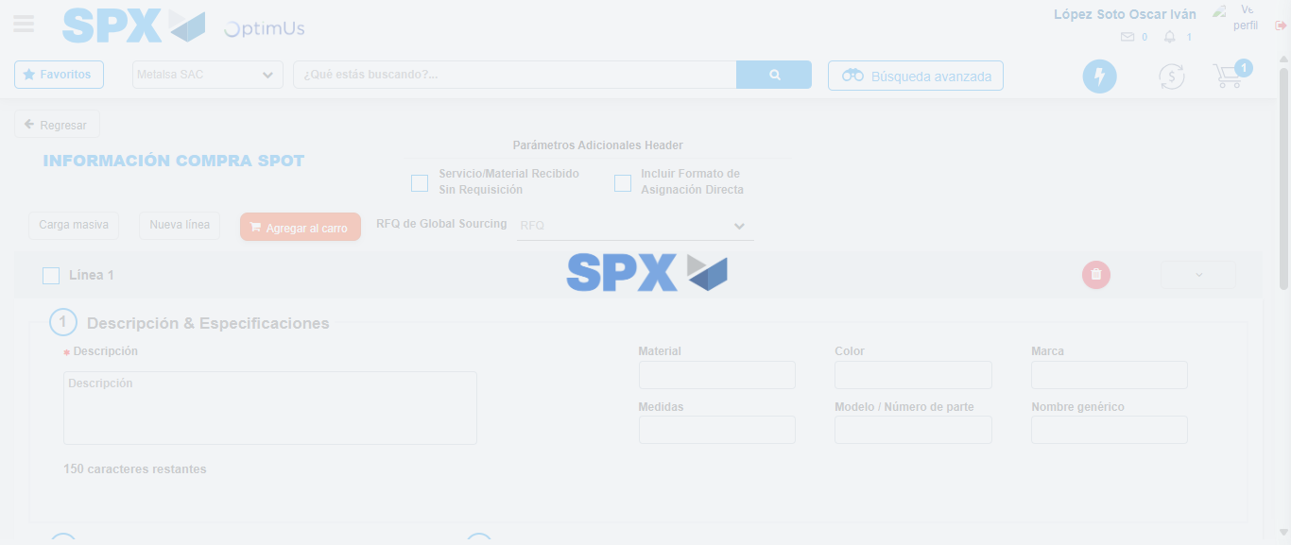Image file-name: QC_Testing-tc005_SPX_Dev5_Crear_Requisicion_Spot_Con_FAD_Tipo_Cobro_Project-1784571822753

Step 8 - Return to Main Page SPX : Return to Main Page SPX
Image file-name: QC_Testing-tc005_SPX_Dev5_Crear_Requisicion_Spot_Con_FAD_Tipo_Cobro_Project-1784571757586

Image file-name: QC_Testing-tc005_SPX_Dev5_Crear_Requisicion_Spot_Con_FAD_Tipo_Cobro_Project-1784571760192

Image file-name: QC_Testing-tc005_SPX_Dev5_Crear_Requisicion_Spot_Con_FAD_Tipo_Cobro_Project-1784571779942

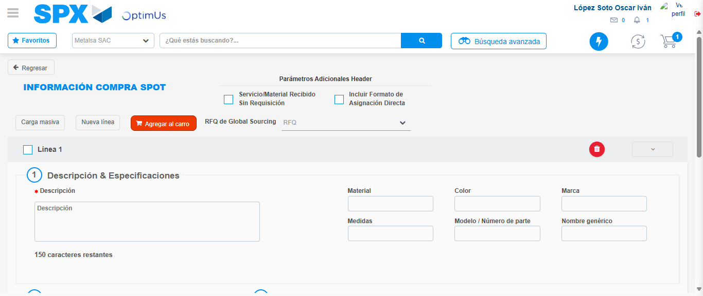Image file-name: QC_Testing-tc005_SPX_Dev5_Crear_Requisicion_Spot_Con_FAD_Tipo_Cobro_Project-1784571824990

Image file-name: QC_Testing-tc005_SPX_Dev5_Crear_Requisicion_Spot_Con_FAD_Tipo_Cobro_Project-1784571825182

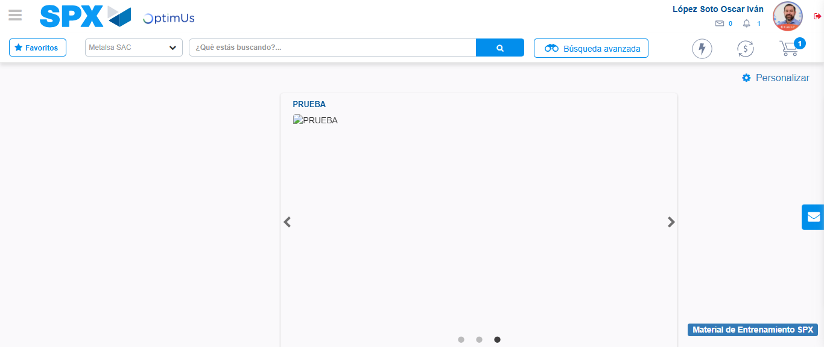Image file-name: QC_Testing-tc005_SPX_Dev5_Crear_Requisicion_Spot_Con_FAD_Tipo_Cobro_Project-1784571846260

Step 9 - Log Out : Log Out SPX
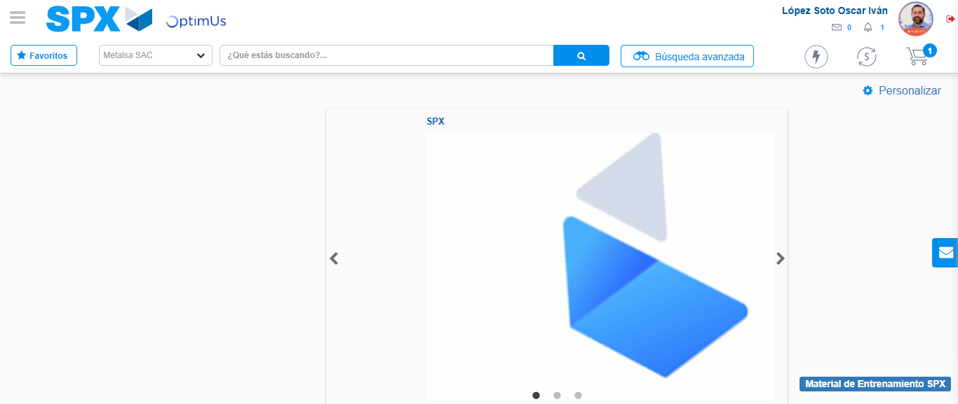Image file-name: QC_Testing-tc005_SPX_Dev5_Crear_Requisicion_Spot_Con_FAD_Tipo_Cobro_Project-1784571846553

